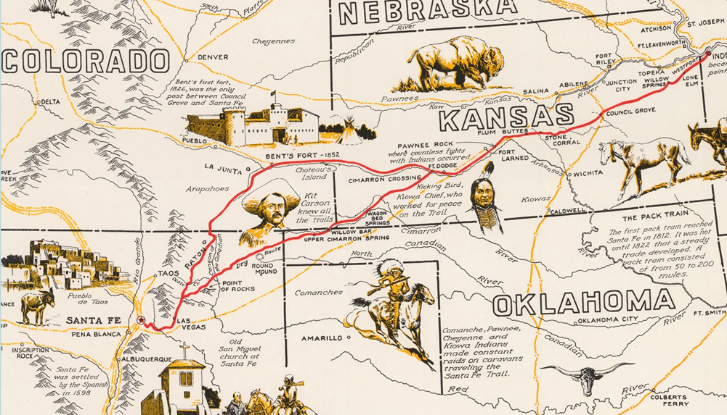

*Image Public Domain. Accessed on May 21, 2024.* Accessible for closer viewing at [11861a.jpg (3000×2194) (shopify.com)](https://cdn.shopify.com/s/files/1/0390/9705/products/11861a.jpg?v=1620324342)

Note: Bent’s Fort first year of operation was 1833, not the 1826 shown on the map. Fort Larned and Fort Dodge were also not established for many years afterwards. Finally, Bent’s Fort was burned in 1849. A “new” Bent’s Fort was erected 40 miles east; therefore, the 1852 date shown on the map is also incorrect.

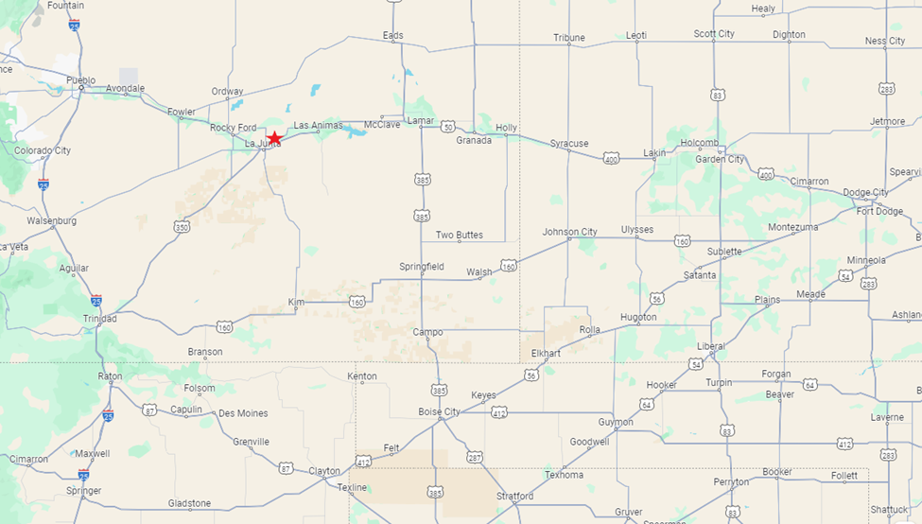

*Google Maps. Accessed May 21, 2024.* Red star shows location of Bent’s Old Fort. Dotted lines show state boundaries. White shields indicate state highway number. Blue shields indicate interstate highways.